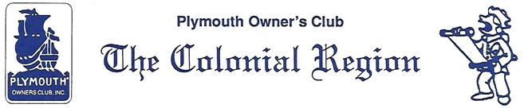

Secretary Minutes

COLONIAL REGION PLYMOUTH CLUB MEETING: March 17, 2019

Members present: Whitmans, Palmers, Nichols, Ruops (plus guests Ryan and Melissa)

The Feb. Secretary’s Report was accepted. There are 4 members who have not renewed todate. The National Plymouth Club is looking for technical advisors for specific Plymouth years.

The April meeting will be on the 14th. Admission to the Stafford flea market is $11.00. Vince’s spot is at the far west side inside the back gate. He will provide hot dogs around 11:30. Region Member parts can be sold at Vince’s spot.

The May 19 meeting will be a hands-on meeting at the Nichols. Lunch will be pot luck followed by a trip to West End Creamery for ice cream.

The June meeting has been changed. We will not be going to Sturbridge for the car show. Judy is working on a cruise with the Hudson Valley Region that our club might turn into a weekend event. No date has been set and more information will follow.

July will be hosted by the Dunleas and September by the Ruops. August has been set aside for those who might want to go to Detroit to the combined WPC/National Plymouth Club meet on August 13-17. This will be the 50th annual WPC National Meet. November will bring us back to Wright’s Chicken farm. The date will be coordinated with the car shows.

Respectfully submitted,

Jane Palmer, Secretary