Adjusting the timing on your Plymouth or Dodge Flathead Six or Slant Six can get slightly more difficult if you have changed the distributor or done a rebuild. You may find the normal adjusting screw and slot VISIBLE from above the engine will not allow for enough adjustment to get the engine timing within specifications. Use of the Timing Adjusting Tool For Plymouth Or Dodge Flathead or Slant Six may be your next step.

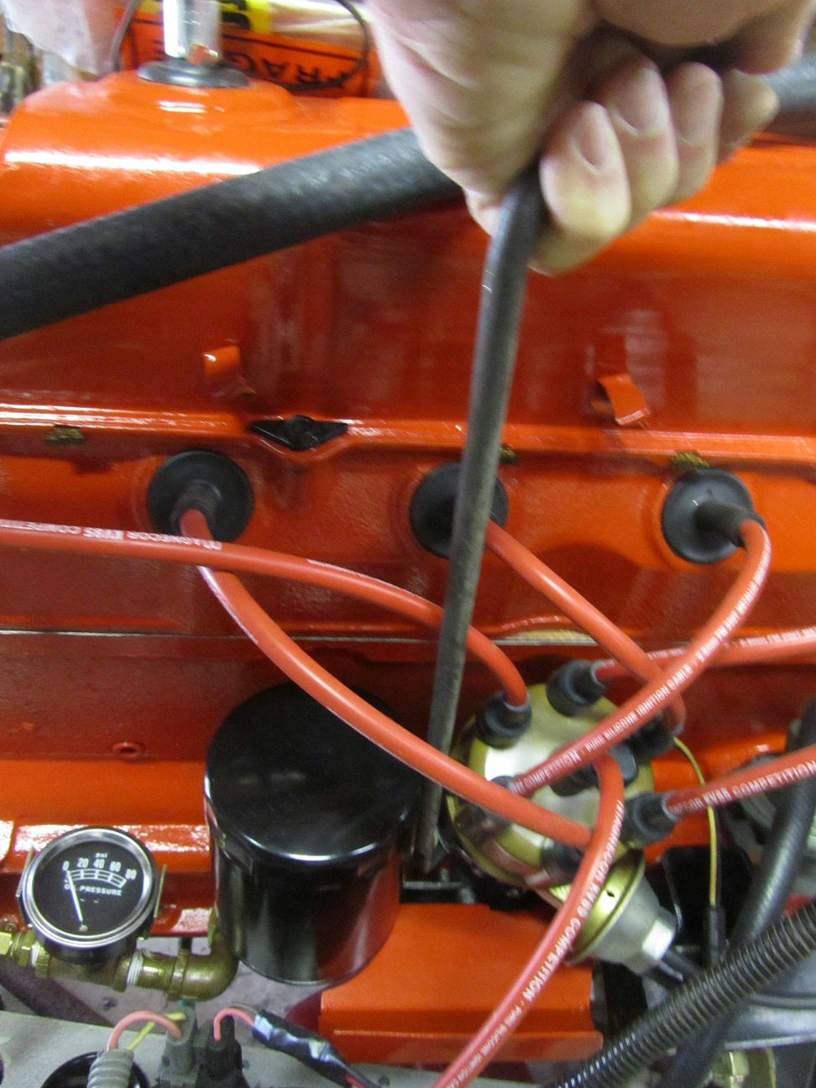

Not visible from above the engine is another timing adjusting bolt that repositions the distributor timing bracket on the distributor resulting in additional adjustment range.

Further explanation follows on the following picture of the tool, the concealed timing bracket adjusting bolt for both the Flathead and Slant Six, and another slot cut in the timing bracket body where the bracket bolts to the distributor:

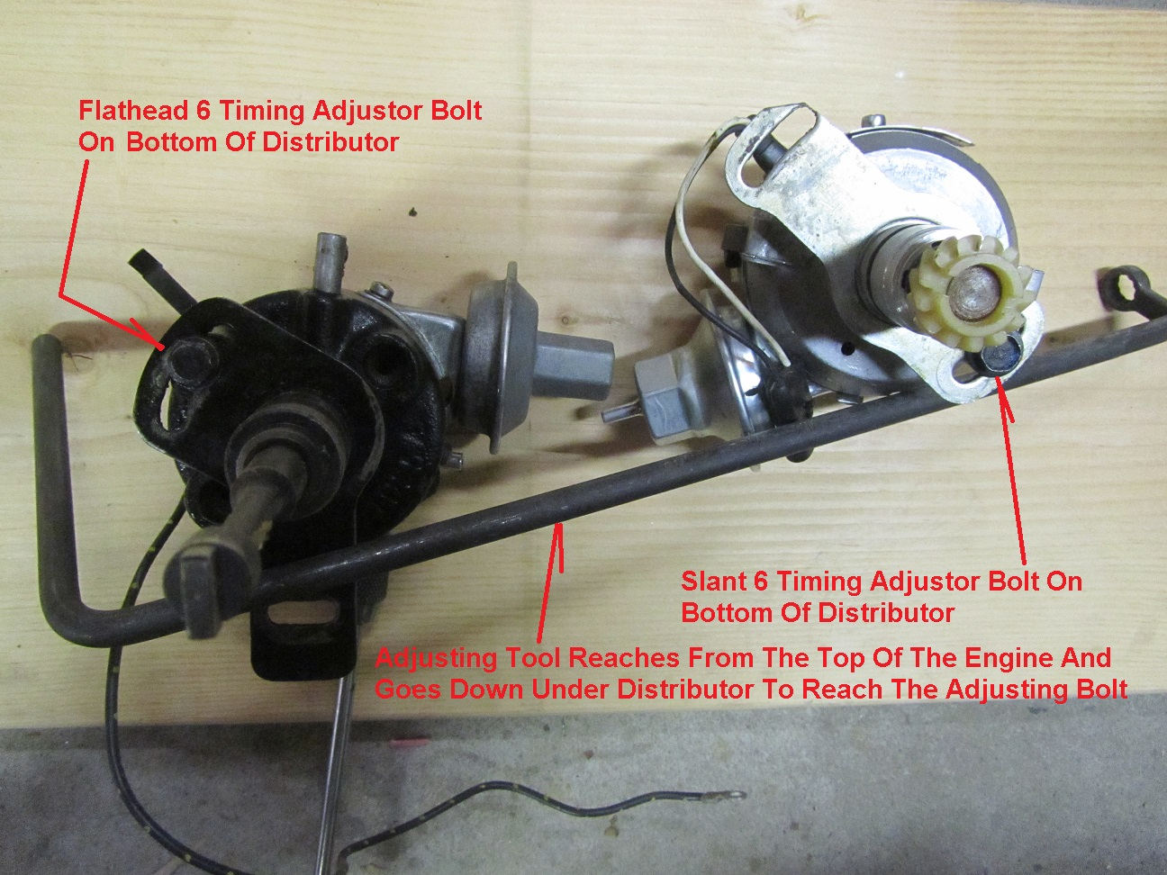

When it comes to "A" bodies like the Valiant and Dart access to the Slant Six CONCEALED adjusting bolt is fairly difficult since the engine "leans over" to the distributor side of the car and the leaning tower of power blocks easy access to components on that side of the engine. Note we didn't indicate passenger side because maybe the car comes from other than the US!

What the tool does is reach down thru a very narrow tunnel of vision and reach under the distributor to engage the adjusting bolt:

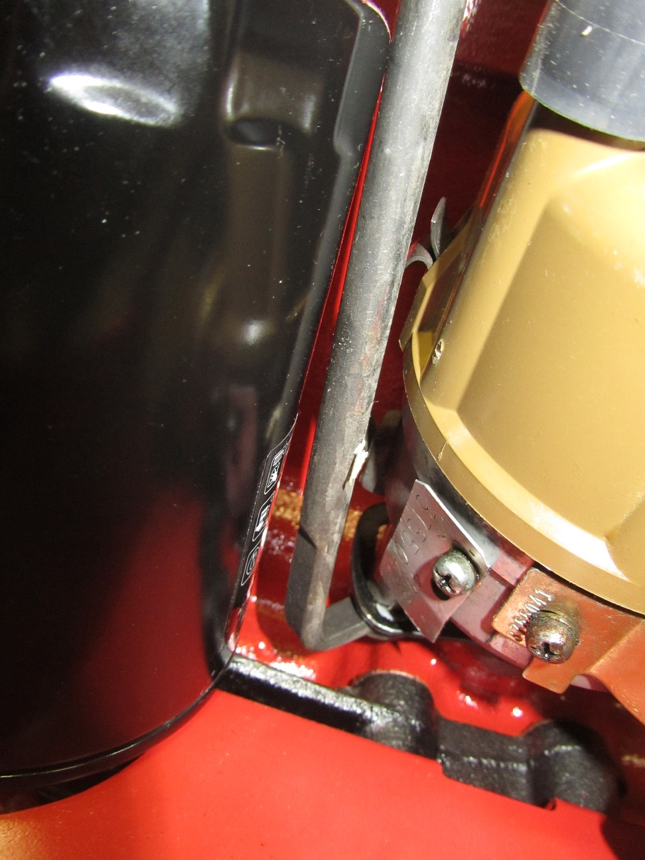

The distributor water shield, oil filter, distributor itself and even the valve cover result in a small tunnel the size of a half dollar to fit the tool to reach the bolt. In practice the VISIBLE timing adjusting screw is set to the middle of it's adjusting range before using the tool to adjust the CONCEALED adjusting screw and rotate the distributor to it's almost perfect position. Then the VISIBLE adjusting screw can be used to fine tune the timing if any further adjustment is needed when power tuning.

This distributor adjusting tool is available at the Colonial Region; sends us a comment thru this website and we will set up a time to pick it.....and of course meet some of our members!