Colonial Region

**SUMMER IS OFFICIALLY COME AND GONE** but we still have time for good driving of our antiques.

Our July picnic at Colt State Park in Bristol, R.I. hit the perfect weather day. Lots of other folks enjoyed it also. It is a very popular destination which includes a nice picnic area with tables and a grill, gorgeous view, good parking, walking and bike trails, and swimming nearby. The Crooks secured a perfect location with 3 tables, shade, and restrooms close by. Reservations were necessary and very reasonable.

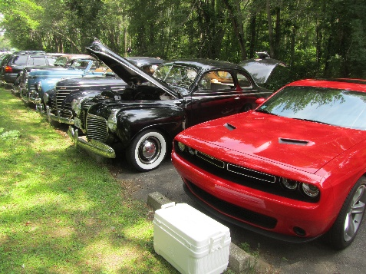

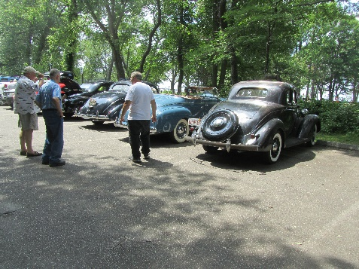

Thanks to the Crooks for arranging that great location. Thanks also to Jim Dunlea, Qin and Doug Crook for manning the grills. Jim entertained the Palmer’s grandchildren with Frisbee. Most of us preferred to stay cool in the shade.

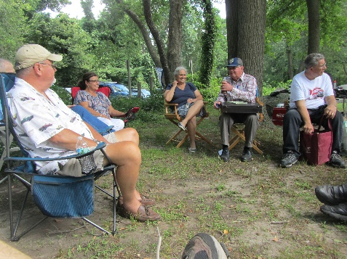

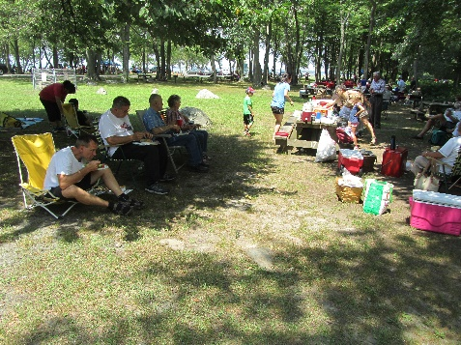

Now that we have started the school year and the color is turning in the leaves it reminds us there aren’t many weeks remaining to cruise around in those antique Plymouths & have our events. So we had our August mystery tour hosted by the Nichols which was a great success. After an ever changing lunch group at the A & D restaurant in Millbury, 12 members headed into the country along beautiful roads to a surprise destination out in the middle of nowhere in Connecticut. We had a short meeting on a picnic table in the shade, while enjoying unique flavors of ice cream. We were the only ones at the Fort Hill Farm and ice cream shop. The weather was perfect as was the view. It was a very relaxing tour, thanks to Bruce for planning such a nice route.

***- Don and Jane Palmer***