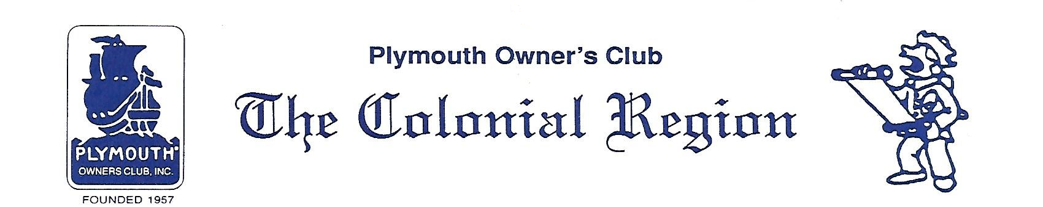
Town Crier News
PRESIDENT’S MESSAGE March 2018
Colonial Region

What a surprise to have warm weather for the February dinner meeting. Even though it was pouring rain and foggy, the Salem Cross Inn Restaurant was cozy and the food delicious for the 17 members attending. All present were reminded to send in their ballots for the National officers. The Palmer’s are planning to attend the Grand National Meet in July.

In discussing membership, we have 4 members who have not paid their dues yet. A notice has been sent to all. We have a unique problem with attendance since our membership is so widely spread geographically. The club will try to have a variety of monthly activities so there is something to interest everyone. We will also try to make the majority of the meetings central to the majority of the members. The latest membership roster will be ready for the March meeting. It will be sent electronically to those with e-mail and mailed to those without. Copies will be available at the meeting.

Starting this month, I will include a list of new technical articles on our web site as well as the items listed for sale. If there is an item of interest, you can have someone access it for you. Please let Don Palmer or me know how it is working. Remember to let Don know if you have something for sale or if you are looking for parts.
ARTICLES- Distributor Cap Quality, Hydraulic Throw-out Bearing Retrofit, Engine Starter Upgrade
FOR SALE- 1965 Plymouth Fury
PARTS WANTED - seat for a 37/38 Plymouth coupe

Our March meeting will be the annual trek to Ioka Valley Farm Pancake Cafe’ in Hancock, Mass on Sunday, March 18.
Meet at the Whitman’s (3326 Hancock Rd/Route 43) at 11:45. We will have a short meeting before driving ½ mile to the farm shortly after 1pm. They have some new items in their boiling shack to sample. The “bourbon- barrel aged maple syrup” is awesome! Members will pay $15 per couple. Tip is not included. Bring your appetite.

Judy

