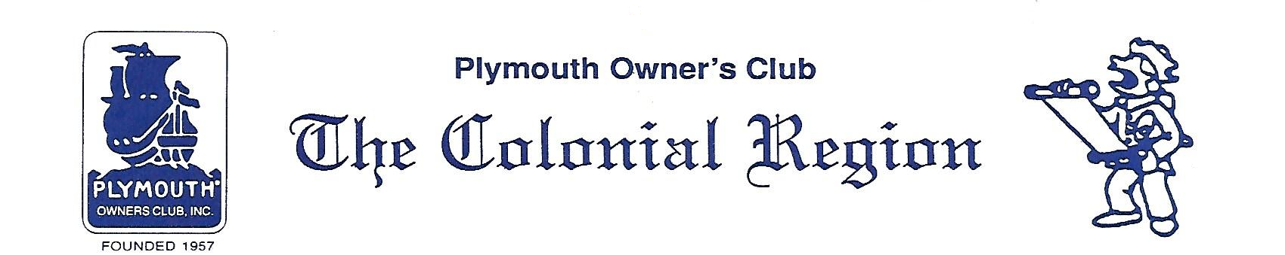
Town Crier News
PRESIDENT’S MESSAGE APRIL 2018
Colonial Region

I can’t believe we still have over a foot of snow on the lawn here. Antiques are snow bound in storage.

I don’t think anyone went home hungry after the March club gathering at IOKA Valley Farm Cafe’. Don Palmer gets the prize for the most spectacular special. And he ate the “whole” thing. The weather cooperated with NO snow storm. A good group of members and 2 guests met at the Whitman’s for a short meeting prior to the gut loading lunch. A detailed report of items discussed at the meeting is contained in the secretary’s report. Please read it.
We are trying very hard to have diversified meetings to satisfy all members. We value your input.

Recent postings on our web site include the following:
ARTICLES: Distributor Cap Quality (Part 1 & 2), Hydraulic Throw-out Bearing Retrofit, Engine Starter Upgrade.
FOR SALE: 1965 Plymouth Fury, 1937 Plymouth 4dr (picture on web is from car show 5/17)
PARTS WANTED: seat for a 37/38 Plymouth coupe
SECRETARY REPORT: March 2018 meeting

Contact Don Palmer or me if you have something to add.

The April club gathering will be at the Stafford Springs Annual Spring Car & Flea Market SATURDAY April 15th
Details are in the minutes. No formal meeting. Questions? Call Don Palmer or Vince Ruops.

Jane Palmer is organizing the May 20th tour in East Windsor, CT. to the Trolley Museum and lunch at Sophia’s.

Bruce Nichols is organizing a tour to a nice antique auto restoration facility in Hollis, NH. Save June 16th.

Judy

