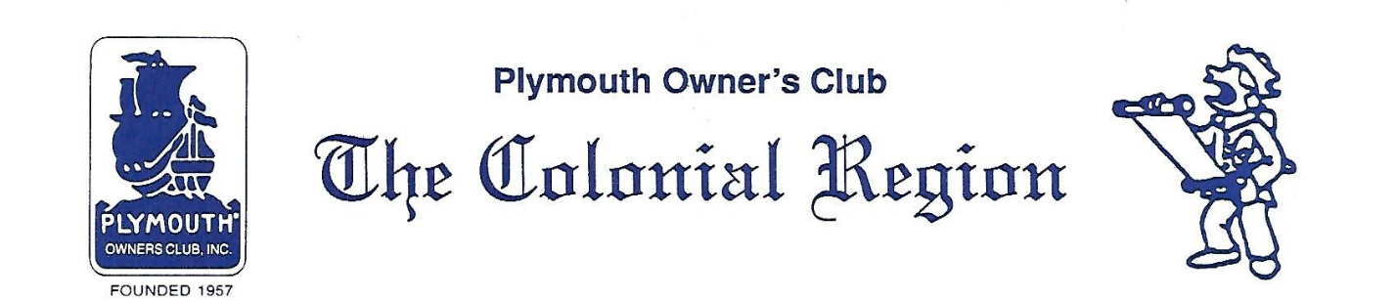

***Town Crier News***

PRESIDENT’S MESSAGE June 2018

Summer has actually arrived and antique car season is officially in full swing. We New Englanders were wondering if it would ever get here. Automobile flea markets, car cruises, car shows,and tours are everywhere, so get out and show that classic. Don Palmer is posting shows and cruises on our web site, so if you have one to announce, let Don know.

The club enjoyed a fun outing at the Trolley Museum in East Windsor, CT in May. After a great lunch at Sofia’s restaurant, we descended on the Trolley museum. The guys gave the trolley conductor a hard time with operating and maintenance questions. A couple of members “***dressed up***”. Check it out on the web site. The day culminated in ice cream in the rain.

We are now sending a survey to all our members. If you are unable to download it or print it, please let me know and I will mail you one. The club requests you bring it to a meeting or mail it back to Judy Whitman or Bruce Nichols. (after you complete it.) You don’t have to sign it if you prefer to remain anonymous.

Don Palmer has posted another technical article on the web site. This one is titled “***5 minute wiring check***”. There are no new “for sale “or wanted items.

Our next meeting is in Hollis, NH on SATURDAY June 16. Info is on the event page of our web. PLEASE let Bruce know if you are coming BY JUNE 13th. Reservations are needed and a good showing Is necessary. This is a nice restoration shop with lunch to follow.

July meeting: being planned by Jim Dunlea on July 15 at his new farm in CT.

August meeting: in planning by Doug Crook for August 19 at a new car museum.

Hope to see you all at the June meeting. Judy