June 2018 Meet

The Meet started at the RMR Restoration facilities in Hollis, N.H. on Saturday June 16 as organized by the Nichols.

Colonial Region members were joined by a Rambler enthusiast:

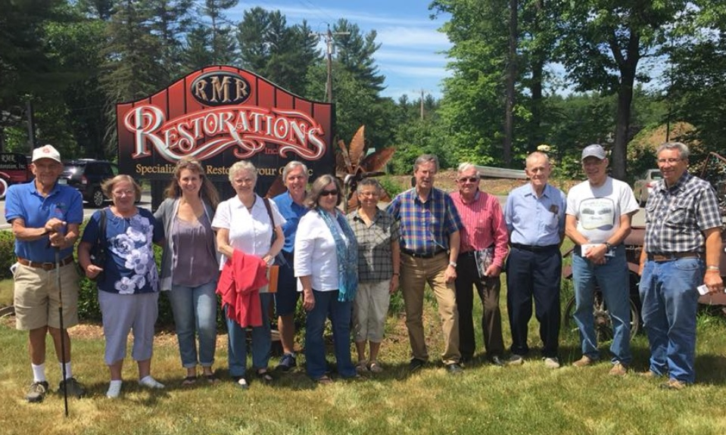

You can research the RMR Restorations run by the Father (Bob Ryan) & Daughter (Christine Ryan) team by looking at their projects and the many photos of each car or truck which show the many skills and capabilities at their website:

<http://www.rmrrestorations.com/>

Colonial Region parked Mopar cars included Tom’s 47 & the Palmer’s 65 parked adjacent to several Region Member Chrysler Vans while the Nichols bright & shiny Challenger was parked out front:

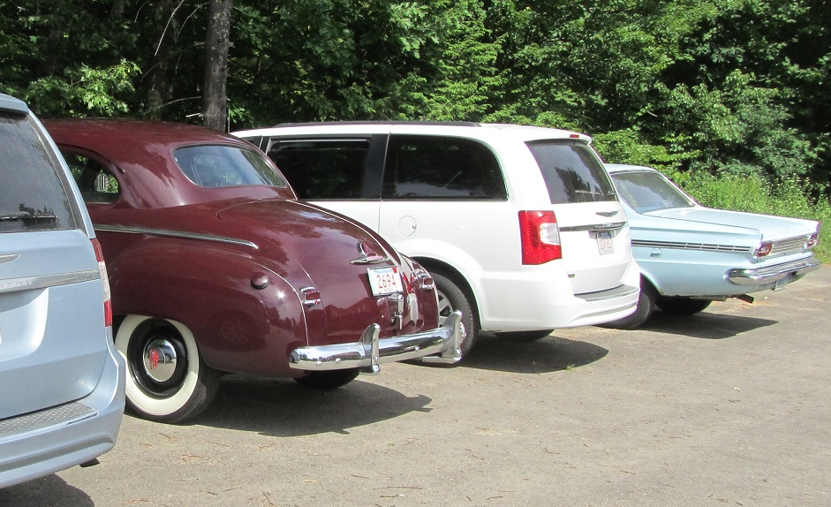

Christine & Mike of RMR Restorations conducted a comprehensive tour of not just their show pieces but each aspect & area of the shop which was extremely impressive. Christine explained that they do a full range of projects from one task such as welding a part for a customer to a complete frame up restoration. If a Colonial Region Member was faced with a problem of a broken casting for a rare part they could bring it to RMR for a weld repair of that single part and that would be a normal RMR service. After a brief discussion in the entry area where Art Works were displayed we moved into the fully equipped Assembly area room which had two rows of cars under a range of different assembly points:

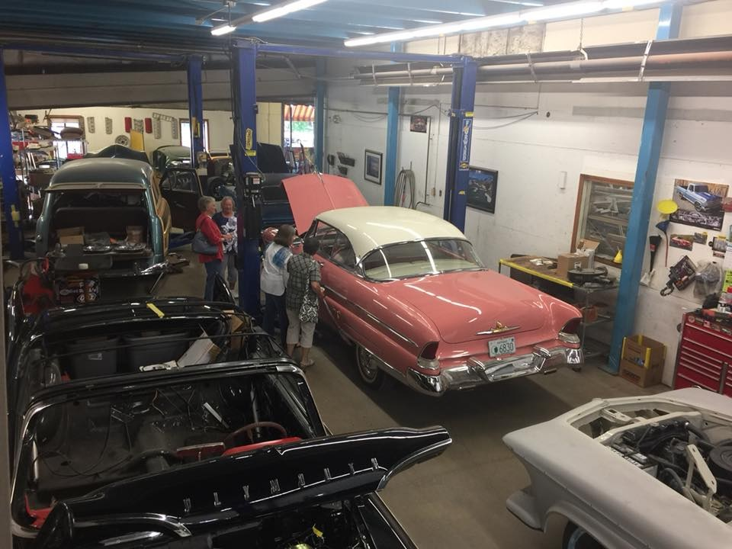

Mopars were everywhere with a near complete 60 Plymouth in the lower left corner of the picture, a less complete imperial, several FMC vehicles including a woody wagon (with Mike’s woodworking skills very apparent) readily visible first off. The line started with several hot rods but ended in the rear with some rare Muscle Mopars including a Hemi powered 68 GTX RR convertible on a lift and 70 Plymouth RR in purple with air grabber system:

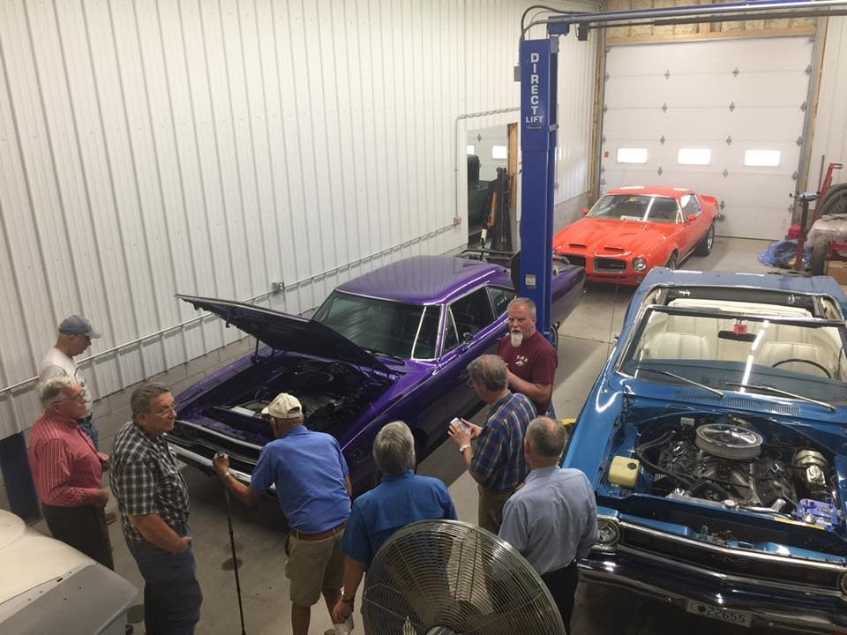

We next moved into a separate room which included several vehicle receiving extensive body repair. A truck bed was being welded together after blasting while a Mustang, LaSalle, and Sedan had a range of body work tasks ongoing:

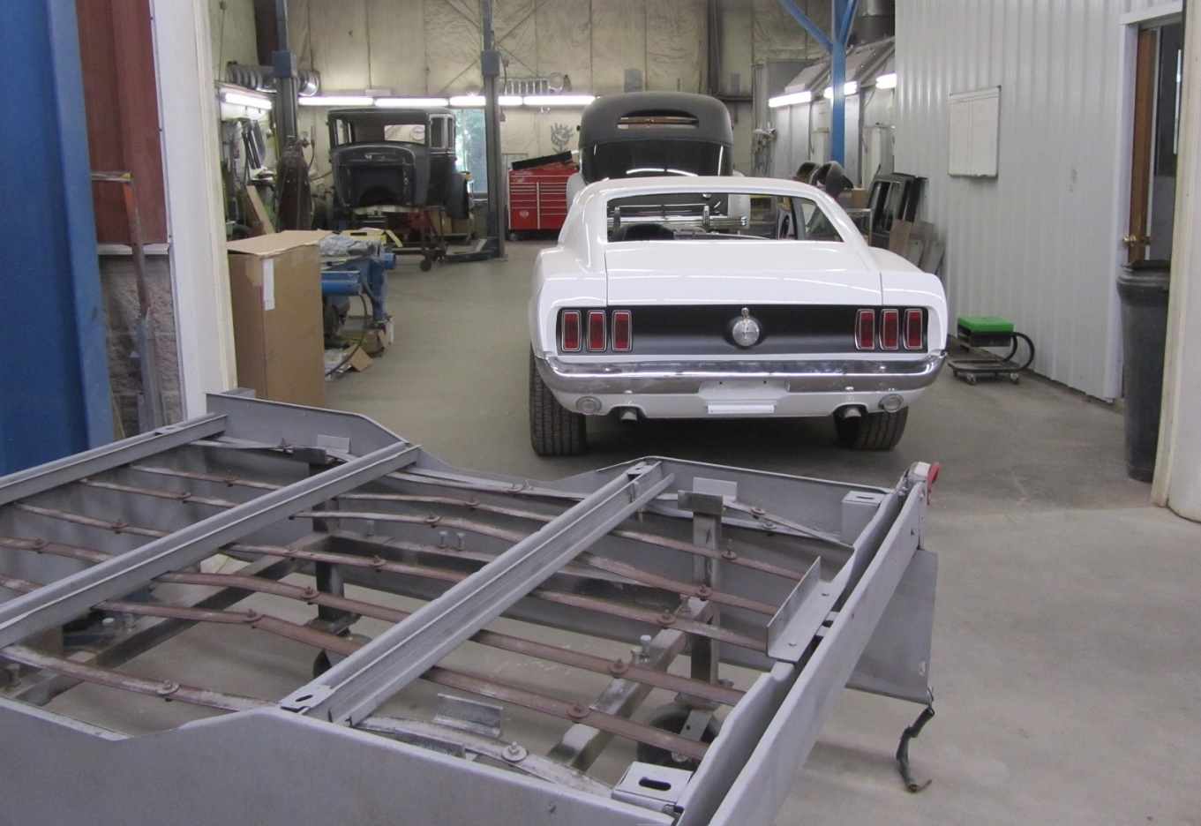

Worker Unique Body Tools were organized on well considered benches reflected “Craftsman At Work”:

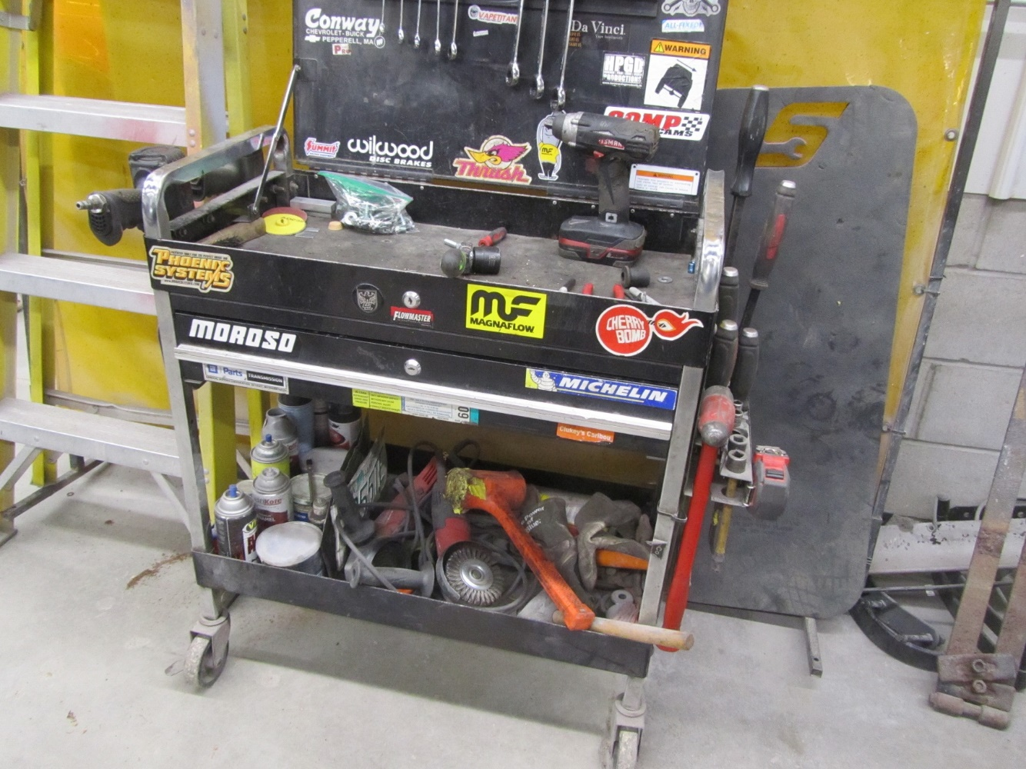

The view from the Body Work Area into the Metal Working Area with it’s extensive great tool resource got my heart pounding:

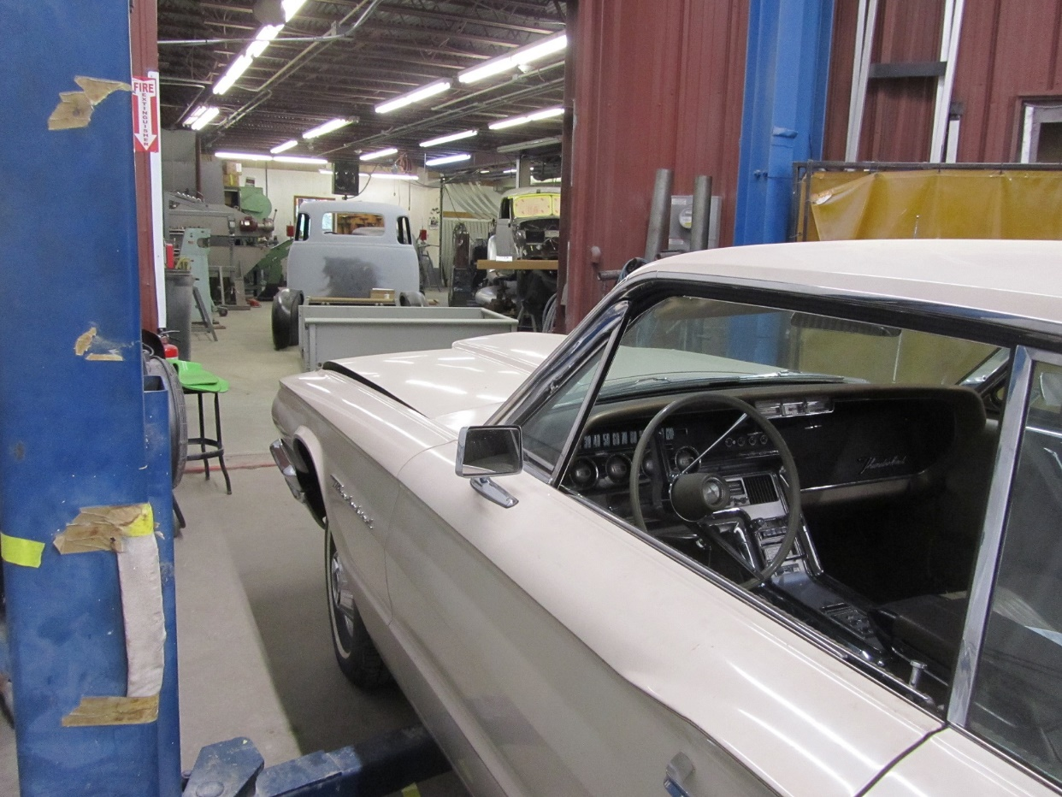

Beyond the 50’s Chevy Truck Bed being welded together out of all new sheet metal parts (also with all new wood flooring) was a gold mine of metal forming tools that was overheating my camera:

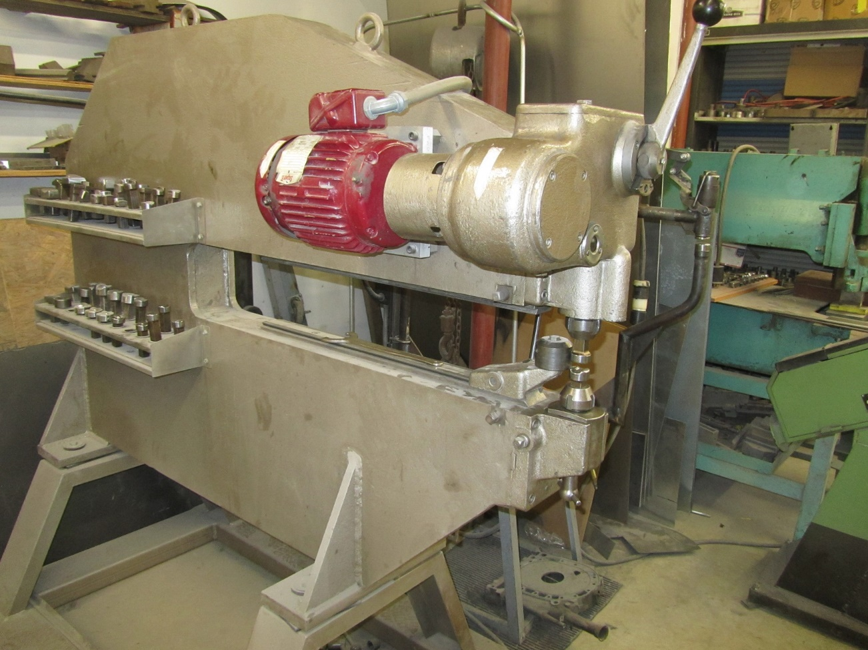

And the camera wouldn’t stop:

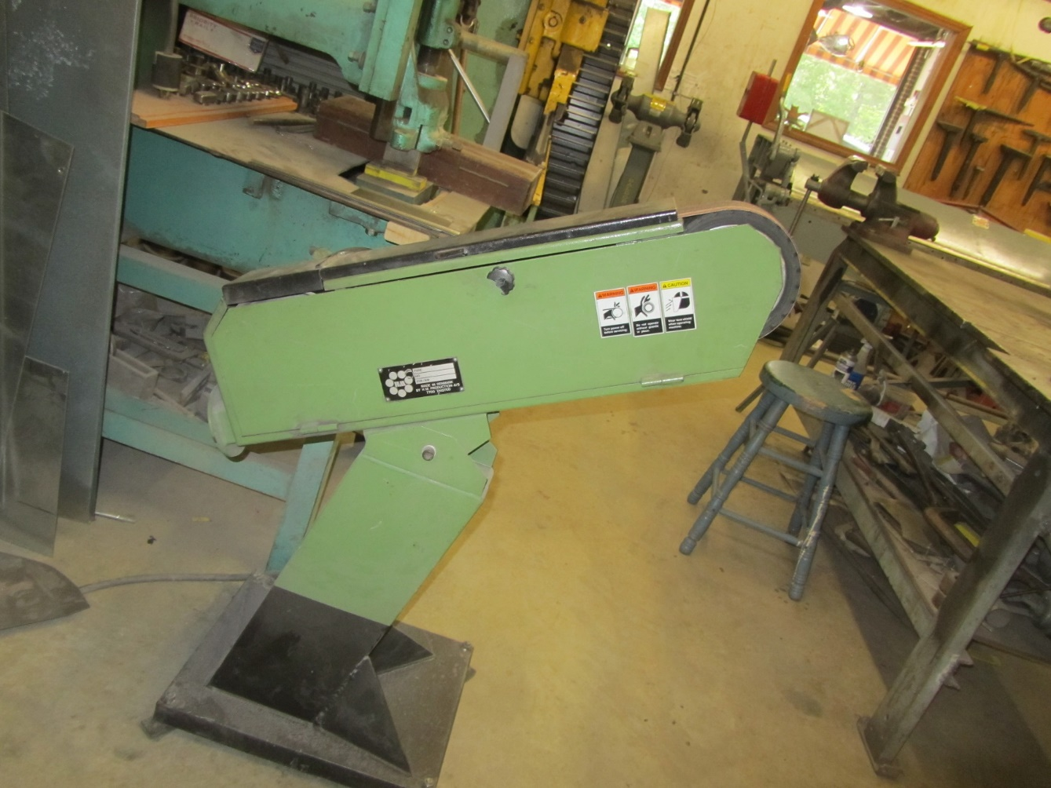

And kept going:

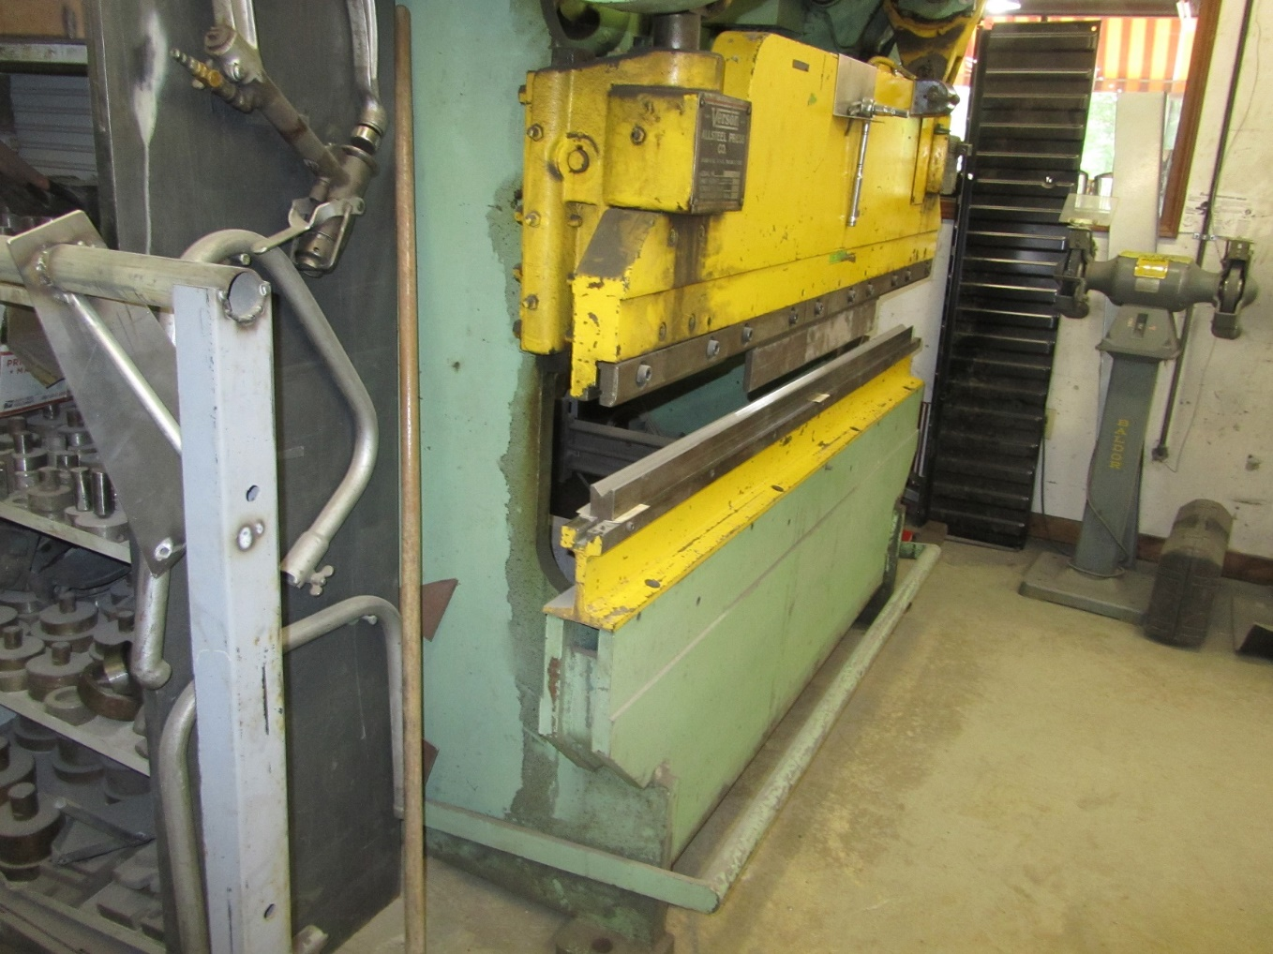

And going:

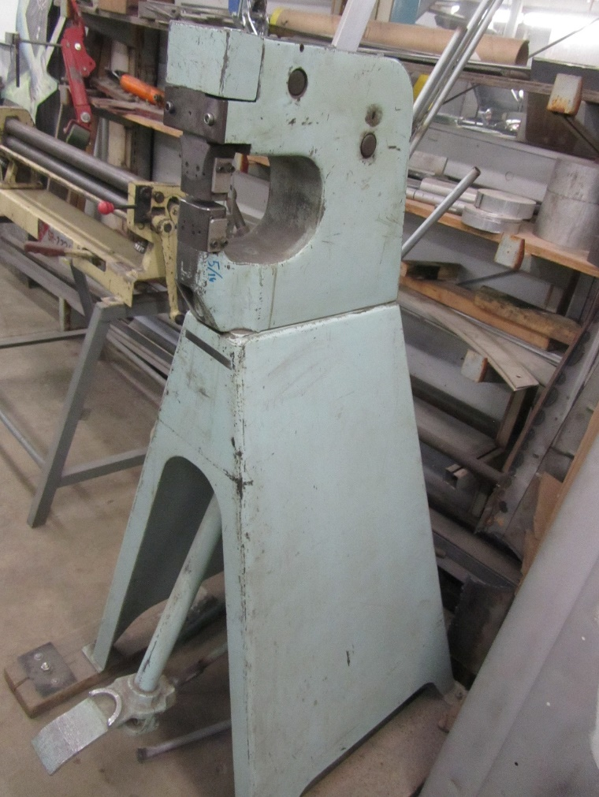

Until the “must have” tool for anyone making sheet metal 3D shaped parts jumped in front of the lens:

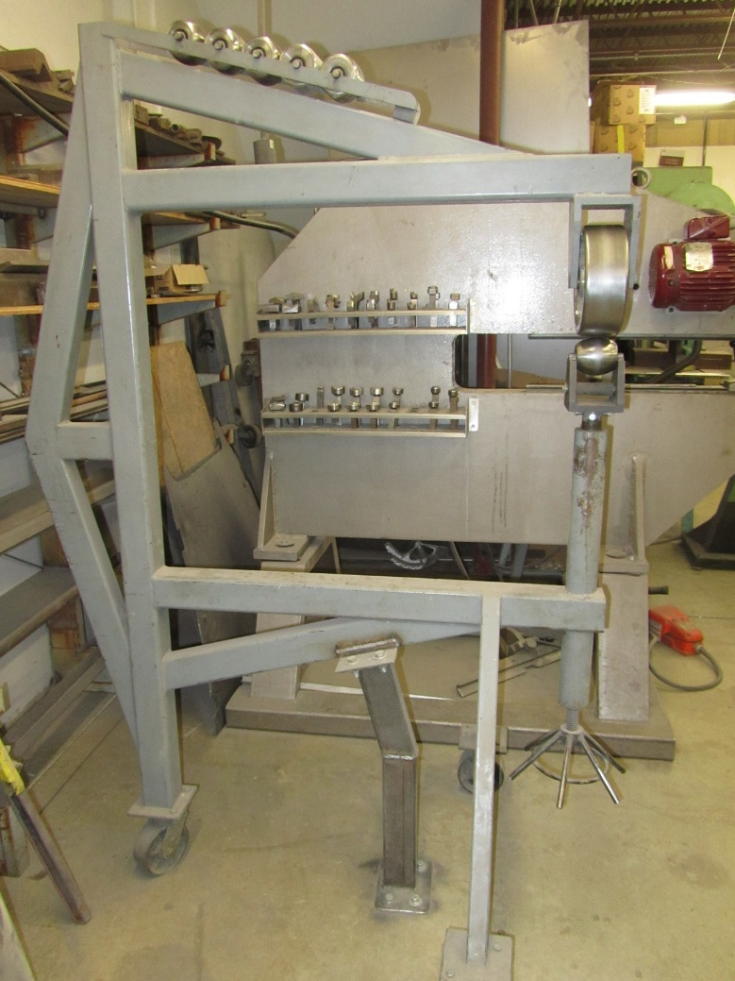

And without this metal chomping tool you don’t even want to use any other:

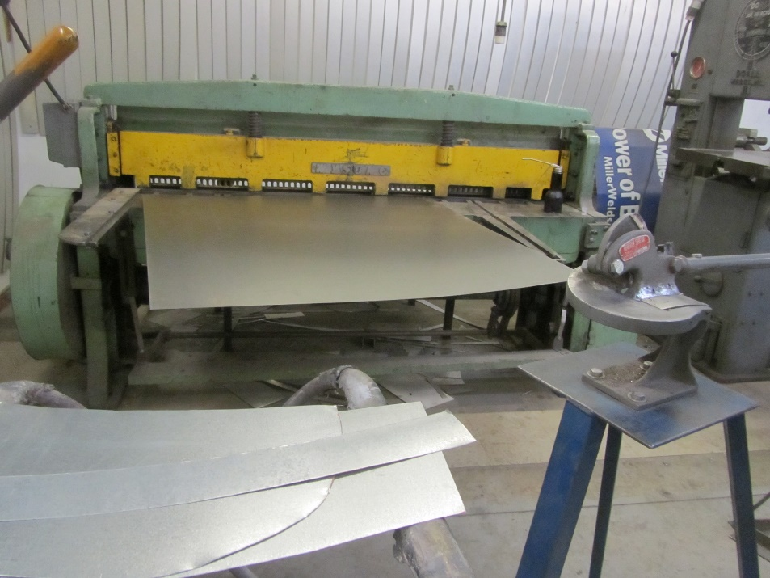

It’s shear madness left the Region Members speechless dreaming about how well it could fix up their prized Mopar:

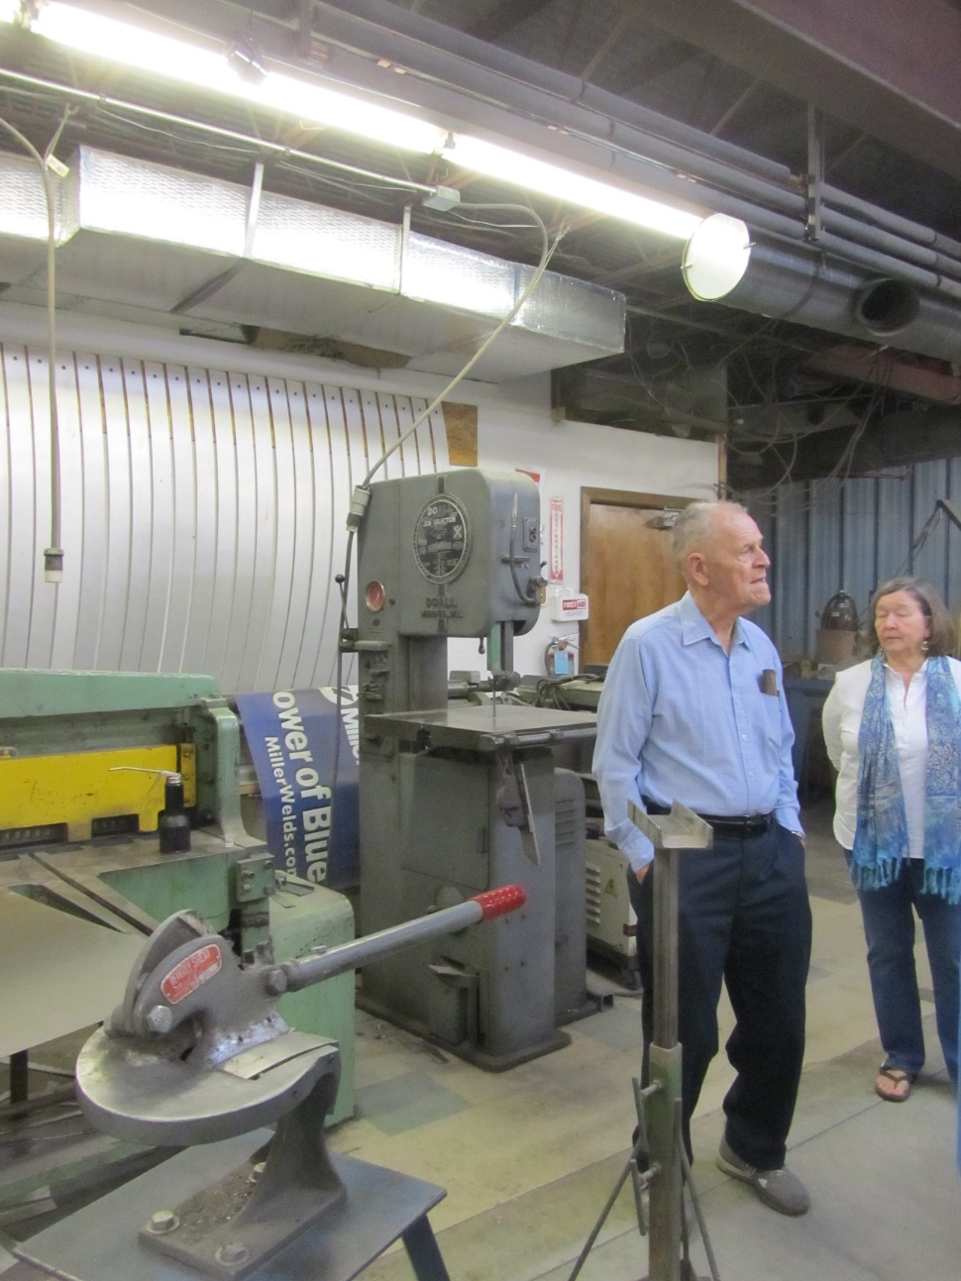

Nearby a 34 Ford Rumble Seat Convertible benefited substantially from the metal forming tools and handiwork of the welder as formed panels were being butted welded into both sides and rear. Beside the Convertible was a pile of the metal panels that had been cut out that showed the extent of damage on the original Convertible when if was first brought into the RMR Restoration Facilities for their care:

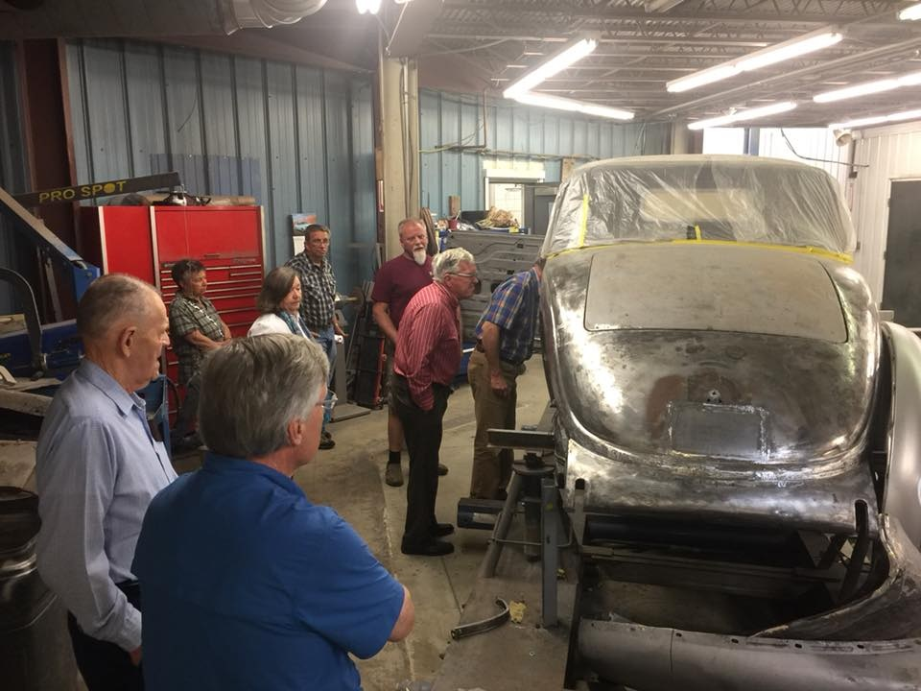

Did that not remind me & my wife of the days of our 33 Plymouth Rumble seat convertible panel work!!!

Region Members then got to see what happens next after the metal & body work in the paint booth area:

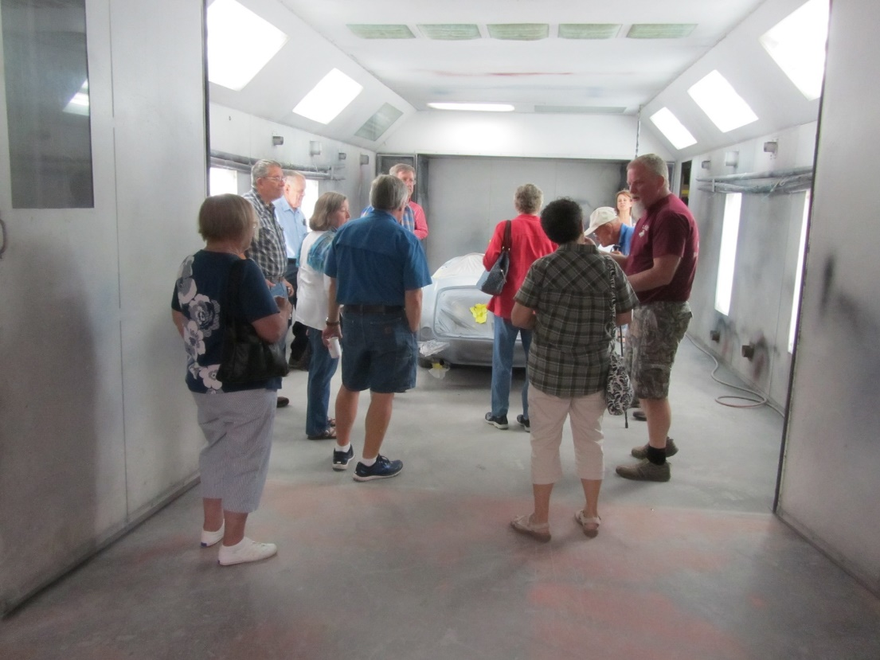

We next went to a small multipurpose room where I’ll bet lunches were eaten over the years but the large number of hanging folders describing the work done to each project caught my eye so I decided this was the “Paperwork” room.

The June 2018 Colonial Region Meet was a great opportunity to get a first hand view of a unique restoration shop with some 15 workers doing fine work for car lovers. We then headed out to a local diner to cap off the day.