Nov. 2018 Show & Food

Region Nov. 2018 Show & Food consisted of:

1. Foliage Drive to Wright’s Chicken on a clear, crisp, calm, & cool day
2. Pre-Food Parking & viewing among many teen to 90’s antique cars
3. Food served in the large banquet area
4. Short, after lunch, meeting (in the parking lot)

A multitude of different year and make cars from the teens to late 90’s filled the special lot and the Region cars were among the many in attendance.

The Crooks had their Plymouth appropriately sandwiched in between a 32 Chev and much older Ford :

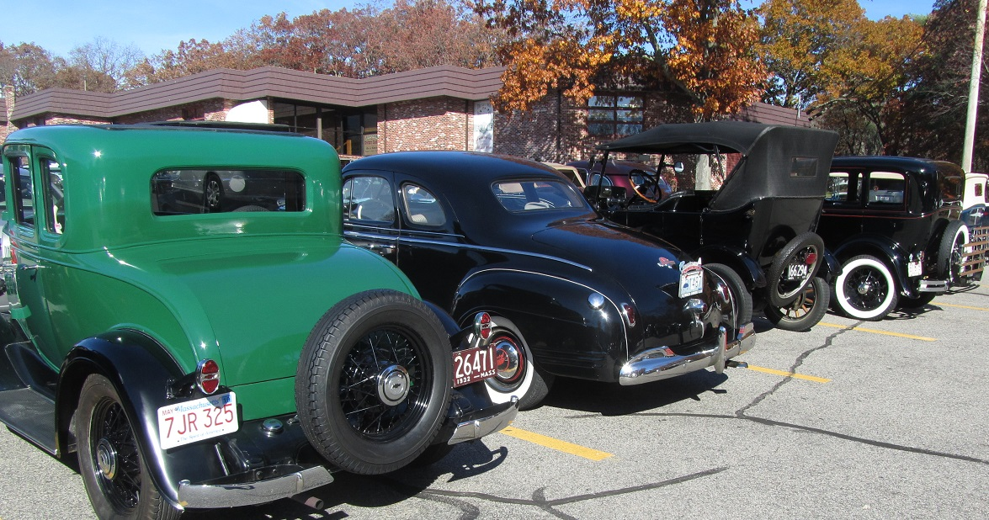

The blue Dart was in between a bright yellow phaeton and Model A conv.:

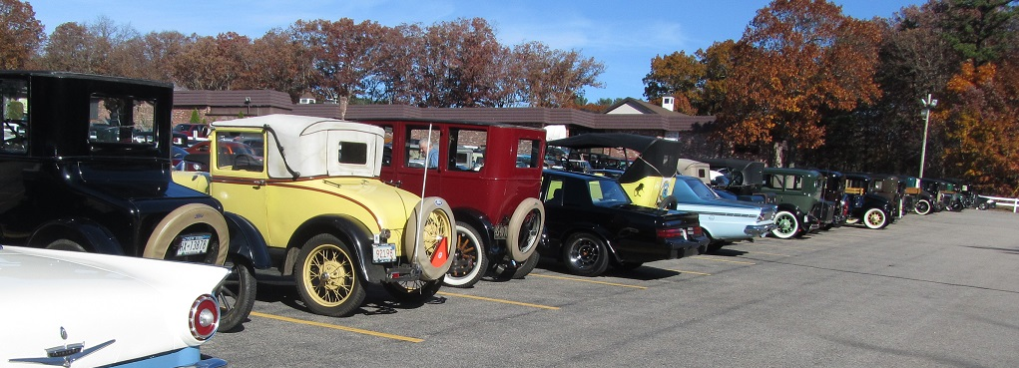

Row after row of cars left one wondering which brand had the most and the least cars? The guess is Ford took the trophy for the most cars:

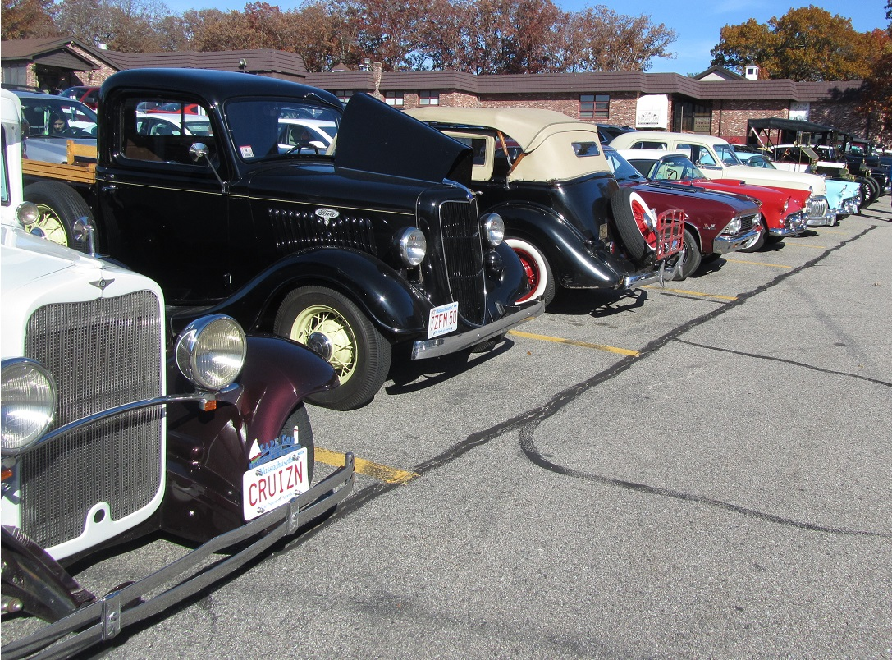

It appeared also that Model A were the most prevalent …….model:

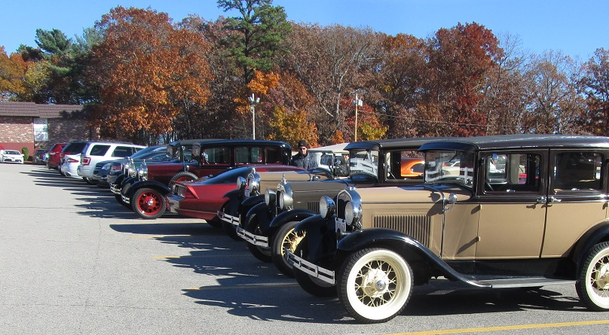

Variety was not lacking since if you had a favorite model it was probably here:

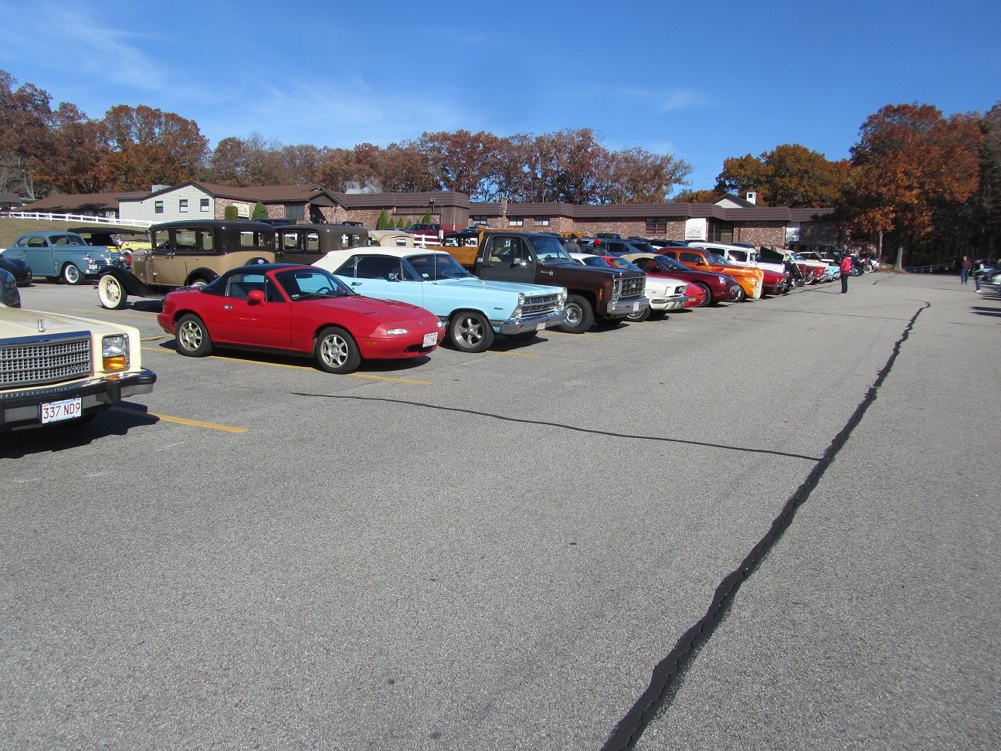

Even a Corvair and Sedan Delivery were planted among the mix of Tbirds:

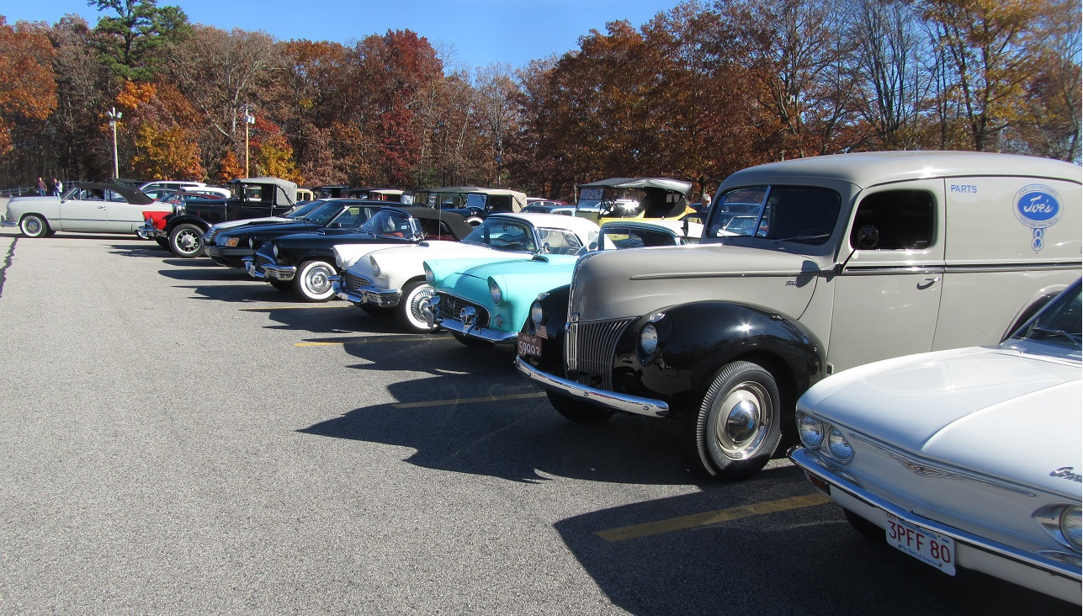

Once past the show field the Region found a spot in the Banquet hall:

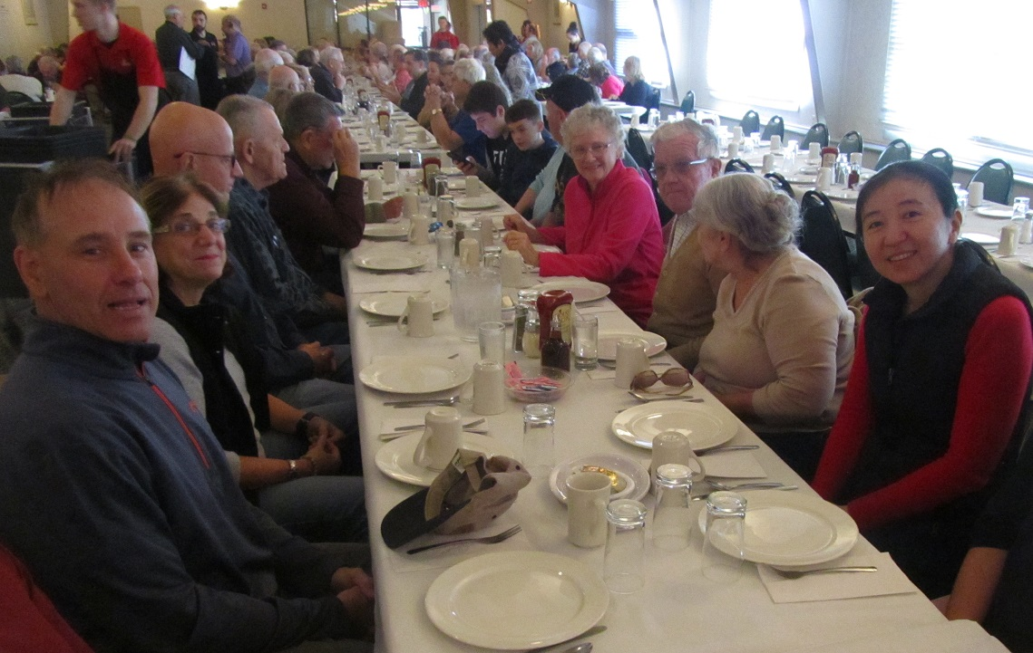

A Proud Red Sox Fan managed to sneak in with us to make sure everyone knew:

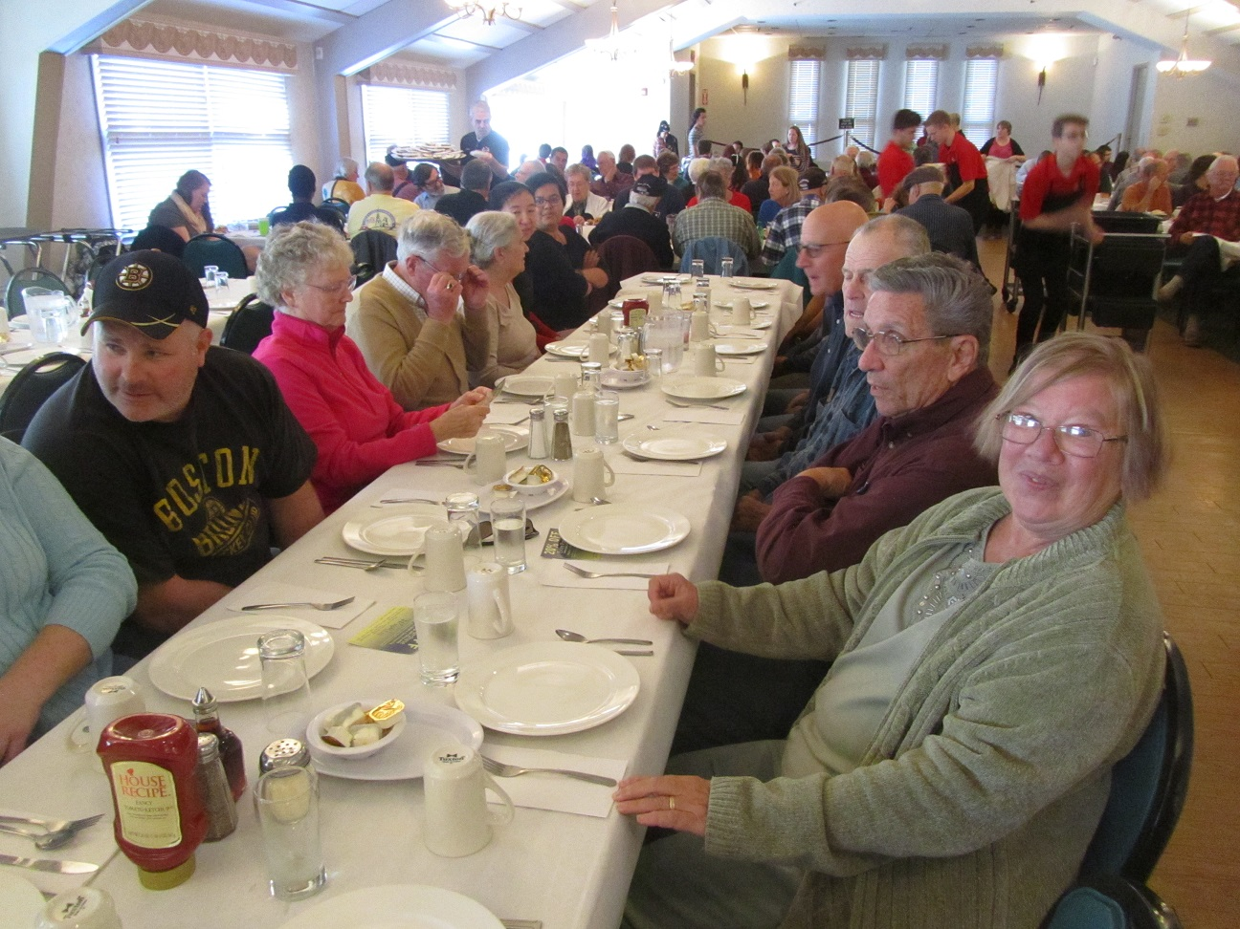

Hope you didn’t bet the Region could not get great weather again like the Sept cruise….you would have lost!!!!