Feb 2019 Region Meet occurred on Feb 10 at the Oliver Wight Inn in Sturbridge, Mass. with 15 members braving the cold winter weather in attendance at noon.

Seven of the Region members came earlier than noon to tour the Sturbridge Village that has buildings dating to before 1830. A period Bank, Church, general store, tin shop, Village pub, and upper middle class estate were included among the buildings visited with period "residents" explaining the customs of the time.

Especially interesting was the discussion of money exchanging hands since many just passed around IOU's or Bank paper since trusted Federal bills were yet to come. It was a system based on trusting your neighbors and friendly bank.

At noon the members gathered at the Inn and sat at two big round tables in a very large room:

[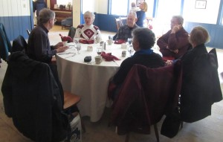](http://www.plymouthcarclub.com/2019/02/feb-2019-region-meet/rounddiningtable1/#main)

[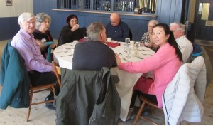](http://www.plymouthcarclub.com/2019/02/feb-2019-region-meet/rounddiningtable2/#main)

A buffet was laid out in an adjoining room with more selection of foods than anyone could ever desire.

After dining the members arranged chairs in the large room for the business meeting which covered treasury report, secretary report, and future meet planning:

[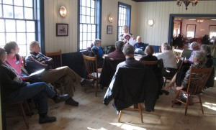](http://www.plymouthcarclub.com/2019/02/feb-2019-region-meet/meetingareadiscussingtreasurysecretaryreportsandmeetplanning/#main)

Plans were discussed 6 months going out so everyone could leave with things to do & mark their calendars.

Weather & road conditions were great for this time of year which added to the Region Meeting success. Hopefully the March meeting in Western Mass. will go as well.